 | 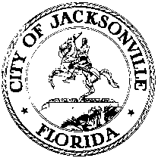
 | OFFICE OF THE CITY COUNCIL
ANNA LOPEZ BROSCHE  PRESIDENT  JACKSONVILLE CITY COUNCIL  OFFICE (904) 630-1452 |  | SUITE 425, CITY HALL  117 WEST DUVAL STREET  JACKSONVILLE, FLORIDA  32202
TASK FORCE ON OPEN GOVERNMENT -AGENDA
APRIL 24, 2018
Lynwood Roberts Room
1:00 pm

- Introductions

- Public access to government through technology
Dr. Cheryl L. Brown-Director, Jacksonville City Council and Paula Shoup-Information Systems Administrator, Jacksonville City Council

- City of Jacksonville’s website demonstration
Chief of Informational Technologies Ken Lathrop

- Closing Comments
Discussion
Approval of previous meeting minutes
Schedule and planning
Survey update

- Public Comment

Chairs: Hank Coxe and Dr. Sherry Magill
Members: Ywana Allen
Rachael Fortune
The Honorable Alberta Hipps
Ron Littlepage
Michael Lockamy
Audrey Moran-Excused
The Honorable Jim Overton
Sabeen Perwaiz-Excused
Cleve Warren

